Worthington Primary School

Worthington Road, Sale, Cheshire, M33 2JJ

Tel: 0161 973 3504

Fax: 0161 976 3210

Headteacher: Mr C N Searle

admin@worthingtonprimary.co.uk

“We Only Reach for The Highest”

________________________________________________________________________________

Thursday 3rd November 2022

Dear Parents / Carers

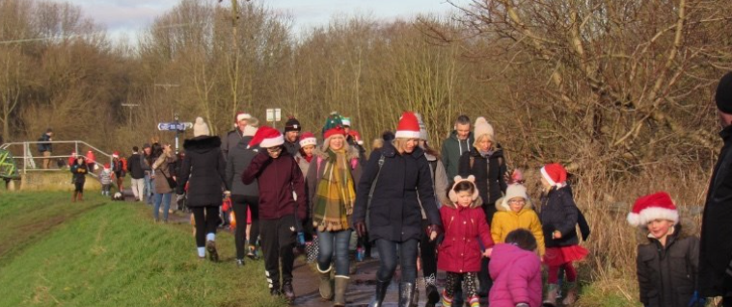

It’s that time of the year again when our Wonderful Worthy Walkers take to the countryside for some fun and fresh air! What are they doing it for I hear you ask? Simply to raise funds for our school.

On 10th December, both Year 2 and Year 4 pupils from our school will be taking part in the ever-popular Worthy Walk. I could not thank our children and parents enough for their enormous fund-raising effort which sees hundreds of pounds raised for school every year.

The walk is a challenging four-mile trek over muddy paths and trails around the River Mersey valley but are they put off? NEVER!

If you would like to donate to this amazing fund-raising effort, you can do so by visiting:

<https://www.justgiving.com/crowdfunding/worthington-pupils?utm_id=1&utm_term=JgKa9Xydx>

The target set by the group is £500 this year – good luck to everyone involved.

Yours

Mr Searle