Extra Resources for Key Stage One during lockdown:
Reading Books | https://home.oxfordowl.co.uk/books/free-ebooks/ | Reading books from different schemes. Matched to book bands. Age 5-6 (letters and sounds phase 4 & 5) Age 6-7 (L&S phase 5 &6)
Maths | https://whiterosemaths.com/homelearning/easter-fun/  https://whiterosemaths.com/resources/classroom-resources/problems/ | Fun mathematical tasks to complete.  KS1 problems of the day!
PE | https://www.youtube.com/channel/UCAxW1XT0iEJo0TYlRfn6rYQ  https://www.youtube.com/channel/UC58aowNEXHHnflR_5YTtP4g | Joe Wicks -morning workout  Oti Mabuse -learn to dance
Music | https://www.bbc.co.uk/cbeebies/watch/playlist-something-special-nursery-rhymes?collection=playlist-collection  https://www.bbc.co.uk/cbeebies/watch/andys-animal-raps-playlist?collection=playlist-collection | Singing and signing with Mr Tumble  Learn some animal raps with Andy
Science | Penda carried the milk to her dad on the grasslands. In the Autumn term we learned that milk was the dairy food group. Here is a reminder of the song we used to help us with our food groups.  https://www.youtube.com/watch?v=vmzJfTlA8nU (food groups)  https://www.youtube.com/watch?v=fNH9IVLWtZs (dairy)  https://www.youtube.com/watch?v=AGnTJQed1t0 (grass to milk)  https://www.youtube.com/watch?v=iWctfIP4GyI (milk to us)  https://www.youtube.com/watch?v=kv2uReha9UM (milk to cheese)  https://www.youtube.com/watch?v=SHqMBaifC18 (milk products) | Recap on the food groups (Autumn Term learning)  Find out more about milk – how does it get to our supermarket?  What can milk be made into?
 | https://www.youtube.com/watch?v=OoqzxjgovUg  https://www.youtube.com/watch?v=wZcYn12Nds0 | Two videos showing how you can grow a mango tree. We have done this in gardening club.  YOU WILL NEED AN ADULT
Art/Science | https://www.woodlandtrust.org.uk/blog/2020/03/nature-detectives/ | Ideas to complete in the garden for example:  - Go on a Minibeast Hunt.  - Make a birdfeeder  - Make Natural Art

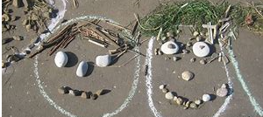
Some more information on Natural Art – see below
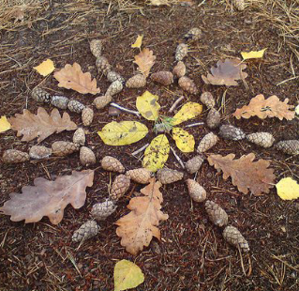
These look like the beastie mask dance.
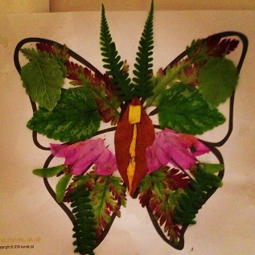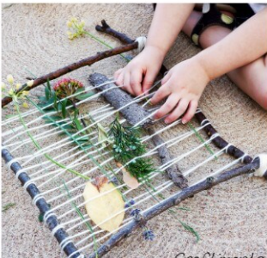
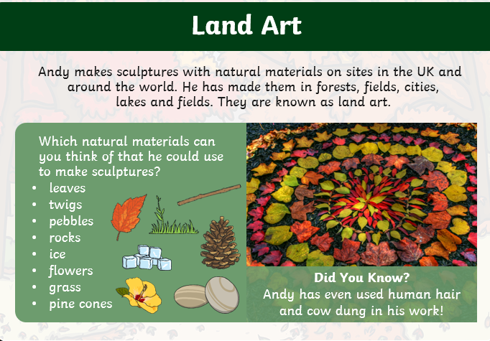
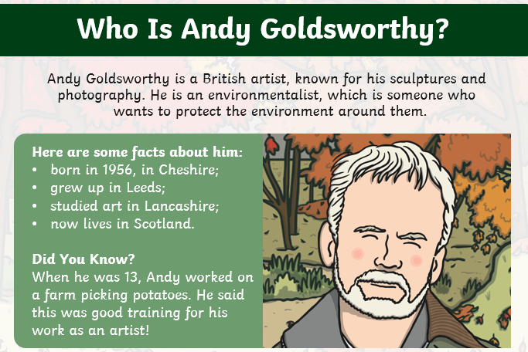
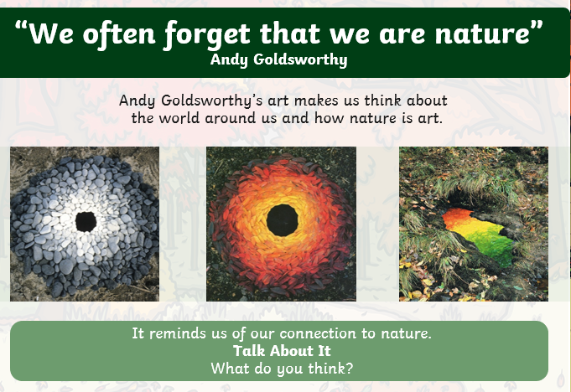
Lastly……….
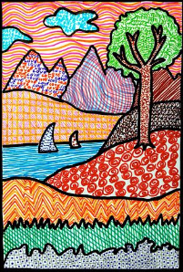
I wanted to share this with you because it reminded me of one of the Van Gogh pictures we looked at last term:
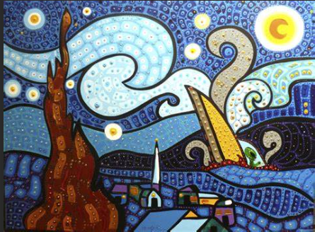
…..but using the colours and style in our book -Don’t Spill the Milk.
Can you make something similar?

