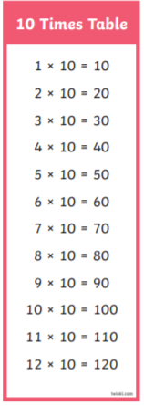
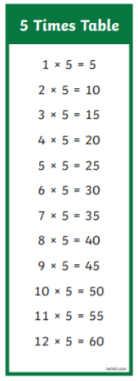
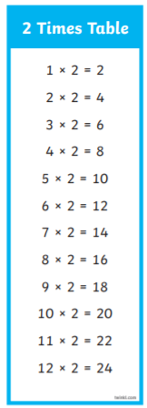
WARM UP GAMES – CAN YOU RECALL YOUR MULTIPLICATION FACTS FOR THE 2, 5 AND TEN TIMES TABLES?
Challenge: Can you write the corresponding division facts? 2 x 10 = 20 20 ÷ 2 = 10

